Assignment 3 Basic Knowledge

Task 1 4 LEDs are connected to Arduino Uno, try to use for cycle structure to make a 1s shift effect.
任务1 使用4个LED连接至Arduino Uno，尝试使用for循环结构，实现1s位移点亮的效果。
You could use Tinker CAD or Proteus for the verifying.可使用在线工具Tinker CAD或Proteus进行仿真。
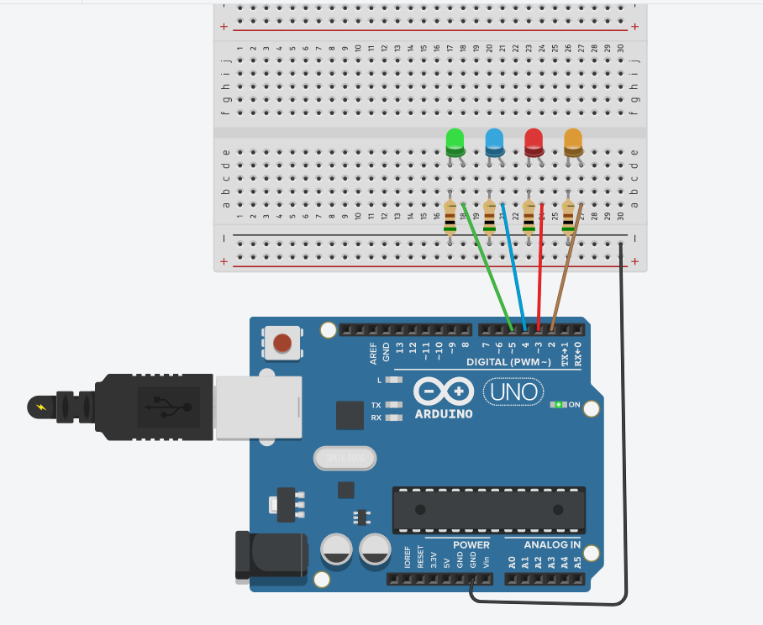
void setup() {
for(int i=2;i<6;i++){
pinMode(i,OUTPUT);}
}
void loop() {
// put your main code here, to run repeatedly:
for(int i=2;i<6;i++)
{digitalWrite(i,HIGH);
delay(1000);
}
}
Task 2 One LED and a POT are connected to Arduino, define a function named getVoltage to calculate the real time voltage of the POT, if the value is larger than 2.5V, then turn on the LED.
任务2 一个LED和一个电位器与Arduino Uno相连，定义一个函数名为getVoltage，用于计算POT段子的实时电压，若电压大于2.5V，则点亮LED。

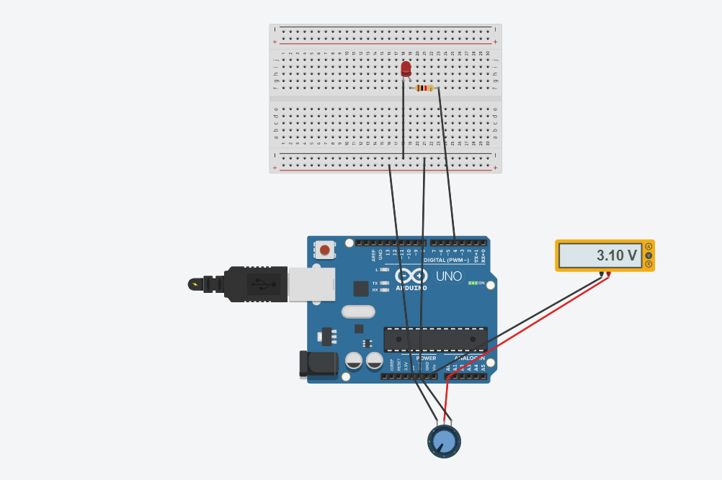

// C++ code
int ledPin =4 ;
int a0 = 0;
float val = 0;
void setup()
{
Serial.begin(9600);
}
void loop()
{
int sensorValue = analogRead(0);
float voltage= sensorValue * (5.0 / 1023.0);
Serial.println(voltage);
delay(100);
if(voltage>2.5){
digitalWrite(4,HIGH);
}else{
digitalWrite(4,LOW);
}
}

